## Introduction /Business Problem

Assume a Torontonian, who recently wants to start a coffee shop business in Toronto area; one of the biggest concerns would be that which location is the best choice to start the business? In this report, we will help to answer such question by analyzing data from the Foursquare.

The target audience would be for those people who want to start a coffee shop business in Toronto, and are troubled to find the correct location. Hopefully by doing this experiment, I can give a promising idea to solve such problem.

## Data

In this report, we will just use the location data from the Foursquare. By analyzing the venue categories of each neighborhood in Toronto, we will decide if the neighborhood is suitable to open a new coffee shop.

For example, a coffee shop is better located in the vicinity of cinema, library, shopping malls, etc. Fortunately, the Foursquare could provide such data for each neighborhood in Toronto. I will examine the types, numbers and distance for each venue, and show strong evidence why the location is good or bad for a coffee shop business.

## Methodology

In order to find the optimal location of a coffee shop, the best practice is to learn from the others. So first we exam the data set to find out the venues types near a coffee shop, and then exam the average number of coffee shops for each neighborhood.

Then we are looking for all the neighborhoods, which have the top 5 venues categories. We choose the least number of coffee shops in the vicinity as the suggested neighborhood.

## Results

Firstly, We find out that for all the neighborhoods which has at least one coffee shop, the top 5 venues categories (besides coffee shop and café) are: Restaurant, Hotel, Bar, Italian Restaurant, Bakery. As I consider Italian Restaurant should be part of the category of Restaurant, I count the 6th place, Pizza Place towards one of the top 5 categories. So the optimal neighborhoods to start a coffee shop/café business should have the following 5 venues categories:

1.Restaurant, 2.Hotel, 3.Bar, 4.Bakery, 5. Pizza Place

Secondly, we find out the average number of coffee shops/café near those neighborhoods are 9.5. With the two conditions: 1. The top 5 categories of venues in a neighborhood 2. Less than 9 coffee shops in a neighborhood, the following neighborhoods met the conditions:

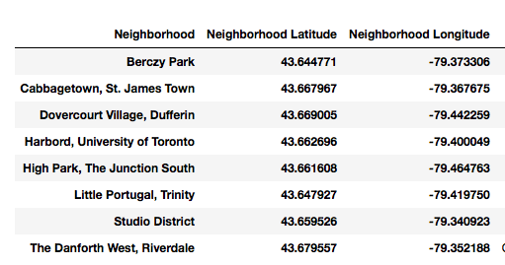

Finally, we calculate the total number of coffee shops and cafés in those above neighborhoods. Here are the results:

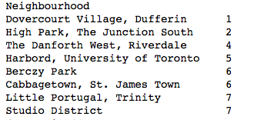

It is reasonable to choose the one with the minimum number as the suggested neighborhood, which is Dovercourt Village, Dufferin. There is only one coffee shop /café in the neighbourhood. The location is {43.669,-79.442}.

## Discussion

From the analysis above, we can find if we just consider the locations, Dovercourt Village, and High park should be a good start to explore on site. They have the top 5 venues that usually a coffee shop/café is nearby, and also they just one or two competitors, which sounds pretty promising.

The shortage of the analysis is that I do not consider the population in each neighbourhood, which is also an important factor in the analysis. Speaking of the improvement of the analysis, definitely population data should take into account.

## Conclusion

This report has suggested an optimal neighborhood for a coffee shop/café business.

It just consider the factors of the venues types nearby and average number of coffee shop/café, and not take the population of each neighborhood into account.

In general, it should be a good reference for those people who want to start a business in coffee shop/café, but I suggest they should not only depend on this report to choose the location.